**Project 01_05_05**

In this project, you will create and reference document elements as a means of generating a table of contents for a document containing the United States Bill of Rights.

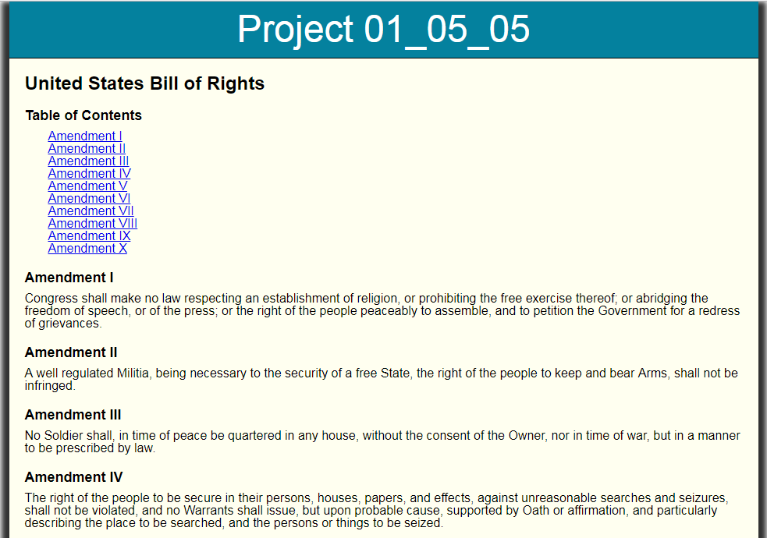 

1. Copy all of the completed files from Project 01_05_05.zip into a Project 01_05_05 folder; this will contain all of the files you will zip up and submit. Open all of the necessary files in your IDE and complete the documentation at the top.
2. Got to the ***index.html*** file and add a ***<script>*** element just before the closing ***</head>*** tag:  
    ***<script type="text/javascript" src="index.js"></script>***
3. Save the file and create a new JavaScript file, ***index.js***. Add all of the appropriate documentation to the top of the file, with your name and the date.
4. Inside the script, create an event handler function called ***createTOC()***. In its code block, add a variable named ***list*** that contains a reference to the only ***<ul>*** element in the ***index.html*** file. Also declare empty variables ***headingText*** and ***TOCEntry***.
5. At the bottom of the script, write code that attaches this event handler to the page ***load*** event. Make sure to put some type of test into the code to make sure everything runs and you have a reference to the ***<ul>*** element.
6. Below the variable declarations, add a ***for*** loop that sets a counter to start at ***1***, and repeats as long as the counter is less than or equal to ***10***, incrementing the counter by ***1*** each time through.
7. Within the ***for*** loop, add statements that perform the following tasks:
   1. Set the value of the ***headingText*** variable equal to the content of the element with an ***id*** value equal to the value of the counter variable. It would be a very good idea to test this as it goes through the loop.
   2. Create a new ***<li>*** element, and assign it as the value of the ***TOCEntry*** variable.
   3. Set the content of the ***TOCEntry*** node to the following:  
      ***“<a href=#” + i + “>” + headingText + “</a>”***
   4. Add the ***TOCEntry*** node as the last child of the ***list*** node.
8. Do a complete test of the Web page, making sure to examine both behaviors and the Developer Tools options.